**DCCN - ISE**

**Date: 17/10/2020**

**Abhir Singh 2018130008**

**Ebrahim Gabajiwala 2018130010**

**Tanay Bagayatkar 2019230065**

**Task 1:** Build the Network and Verify Connectivity

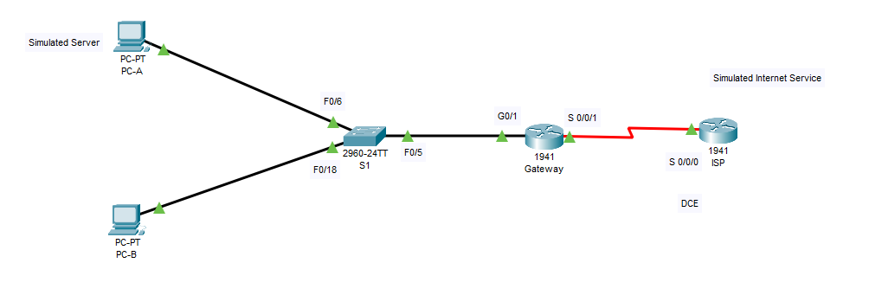

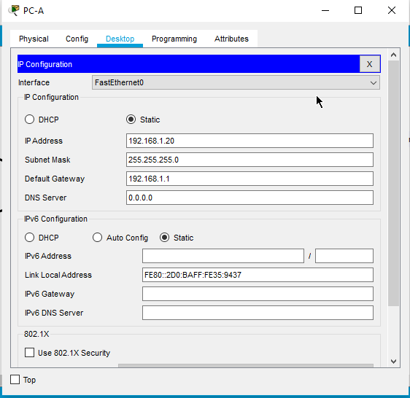

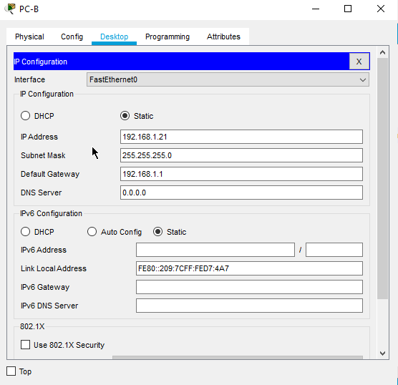

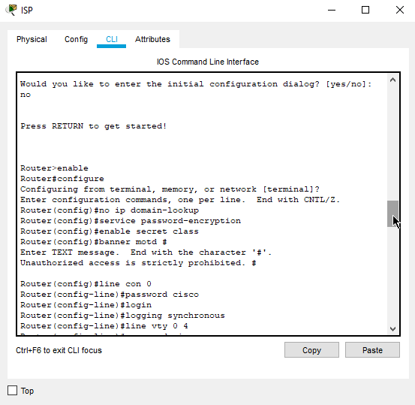

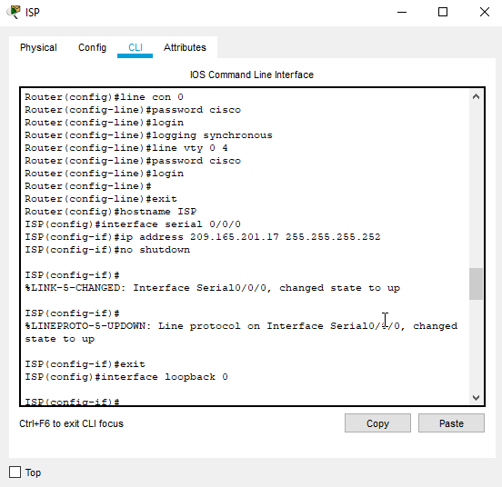

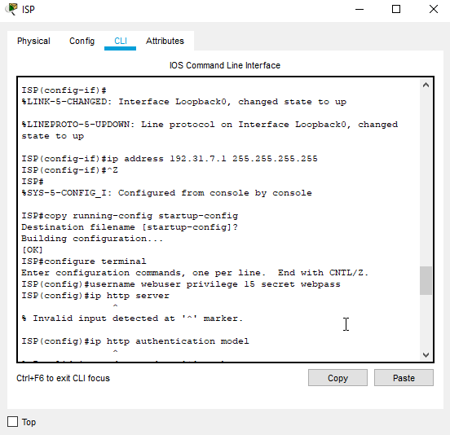

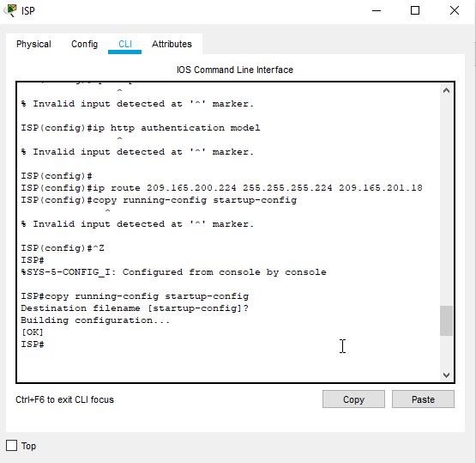

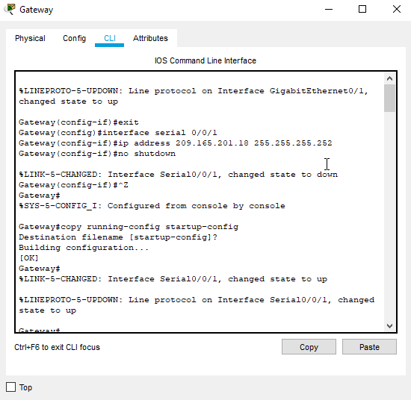

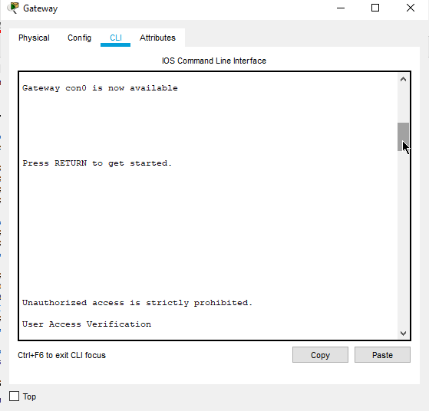

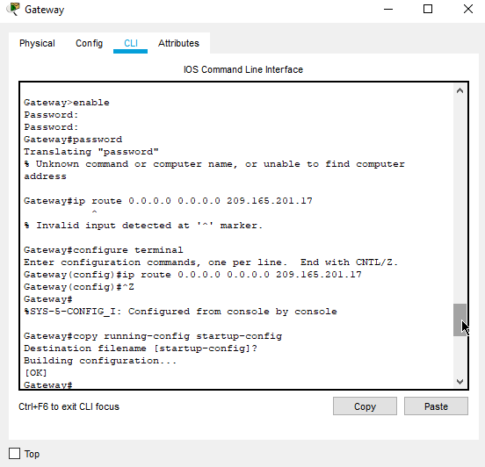

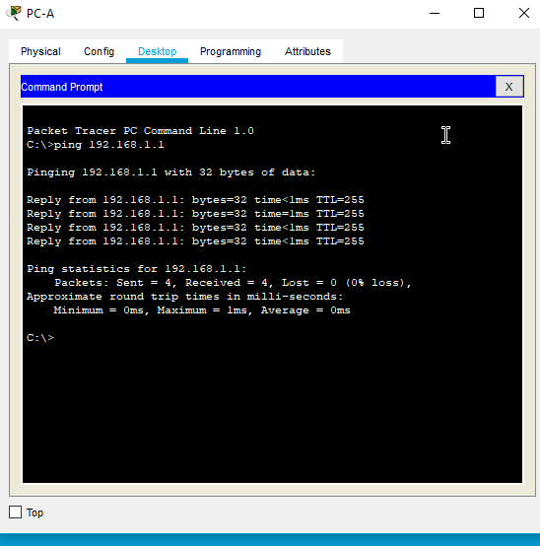

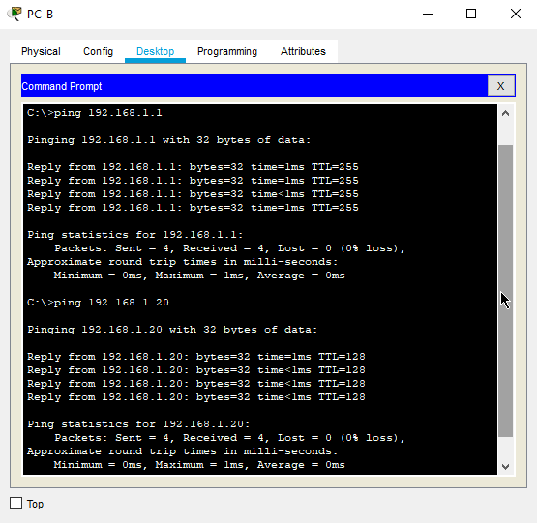

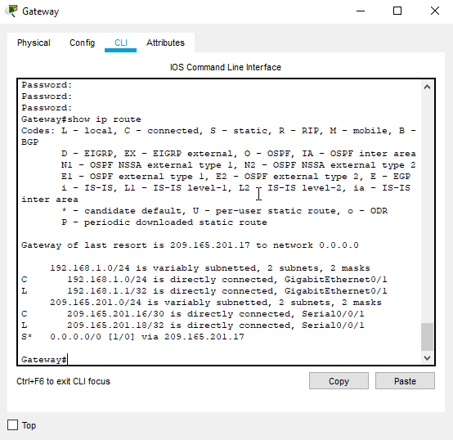

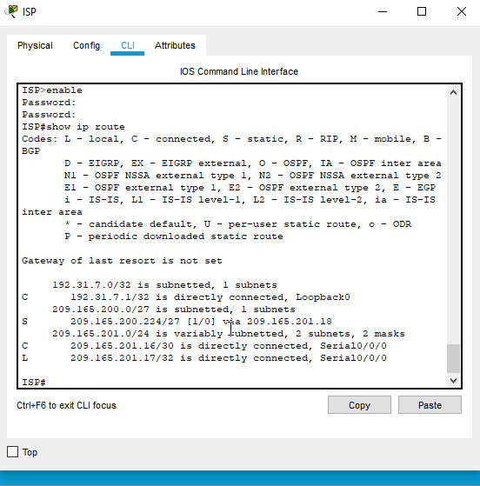

**Task 2:** Configure and Verify Static NAT

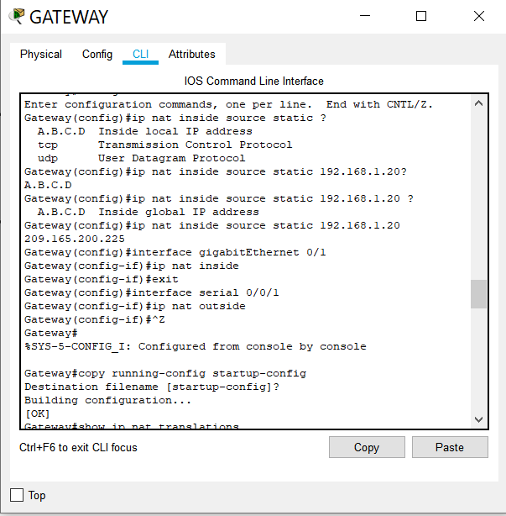

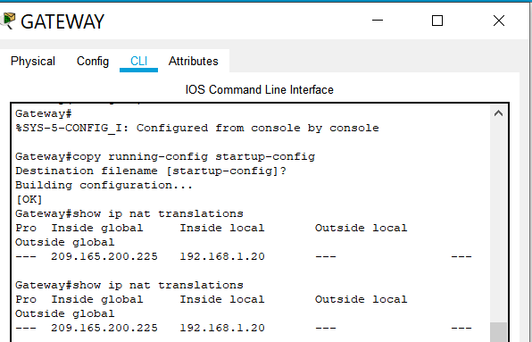

**What is the translation of the Inside local host address?**

172.168.1.20 = 209.165.200.225

**The Inside global address is assigned by?**

ISP(Static) NAT Pool (Dynamic)

**The Inside local address is assigned by?**

System Administrator

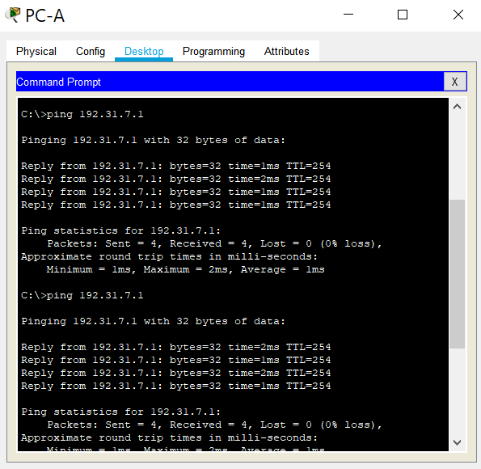

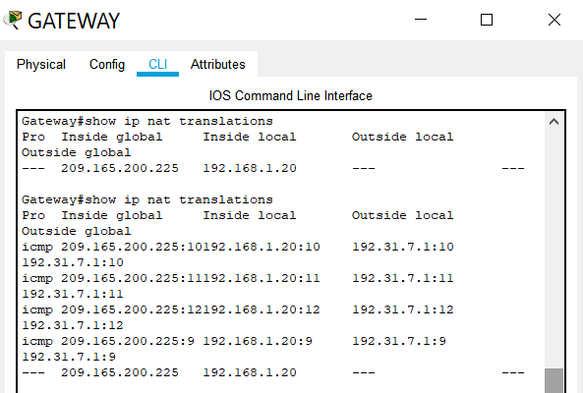

**What port number was used in this ICMP exchange?**

4 port numbers were used for 4 ICMP exchanges for 4 pings.

They are 10 11 12 9

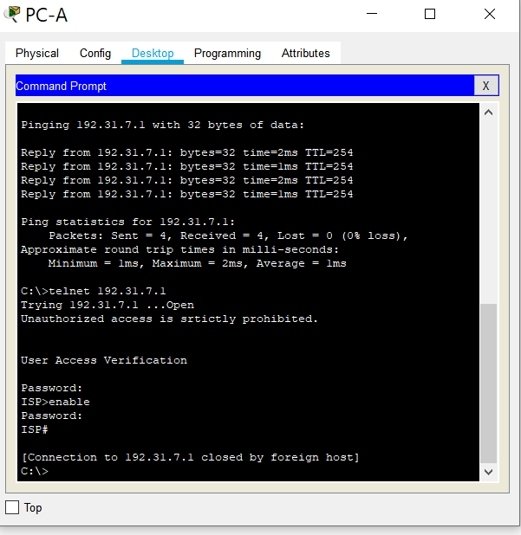

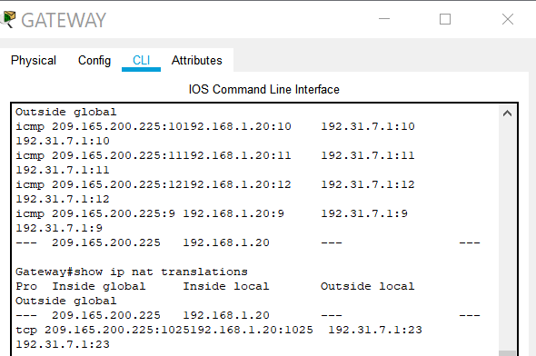

**What was the protocol used in this translation?**

TCP

**What are the port numbers used?**

**Inside global / local:** 1025

**Outside global / local:** 23

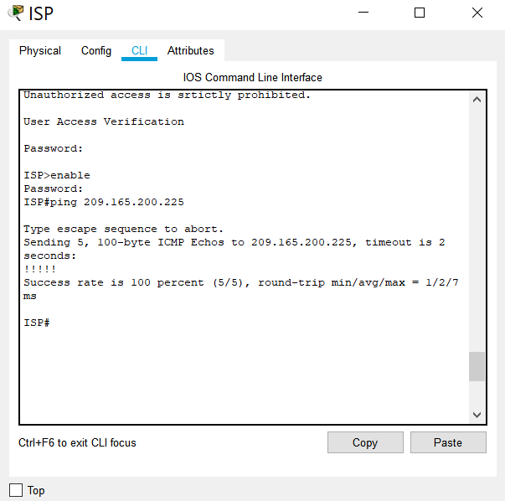

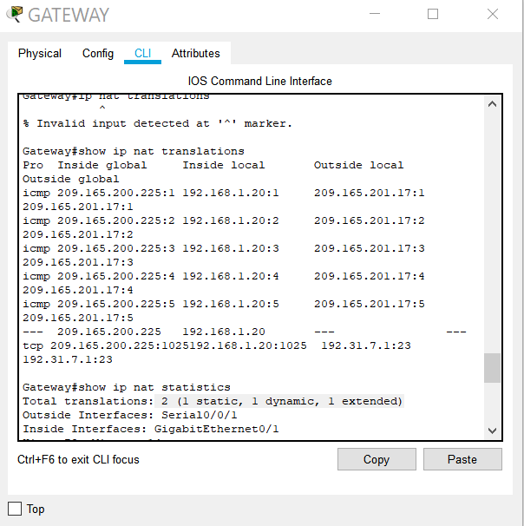

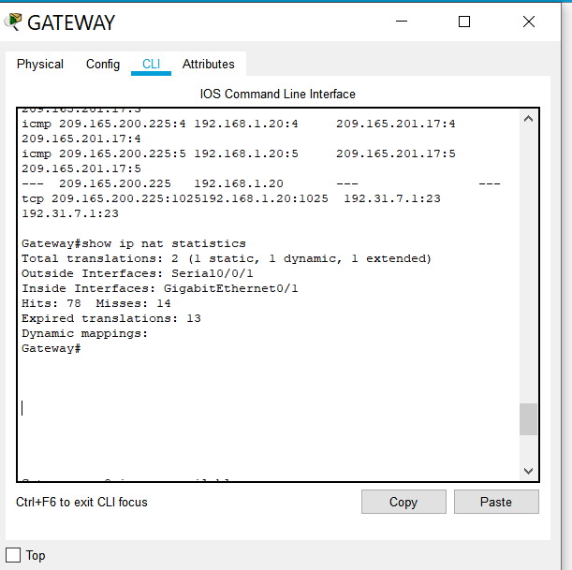

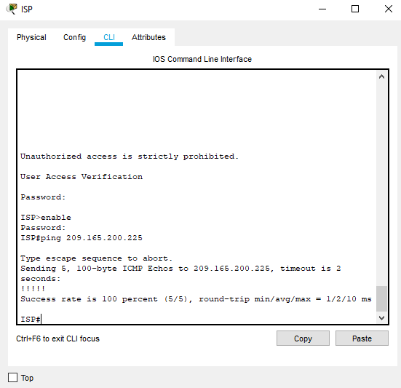’

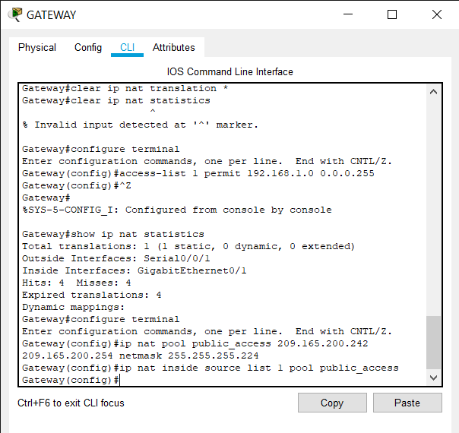**Task 3:** Configure and Verify Dynamic NAT

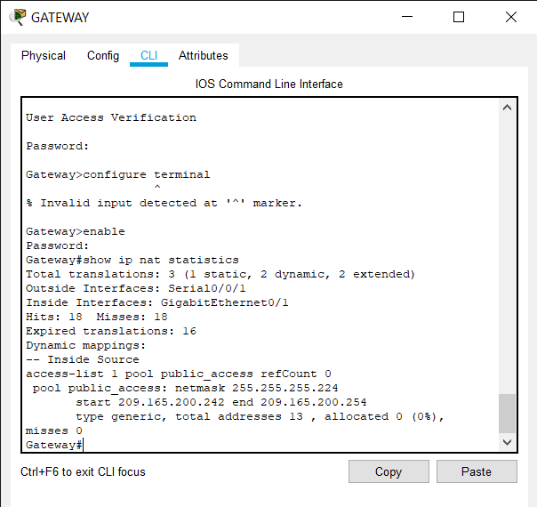



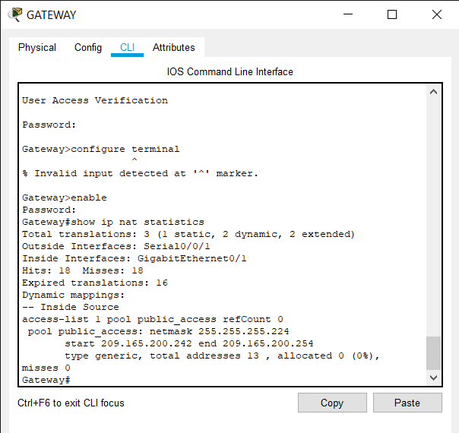

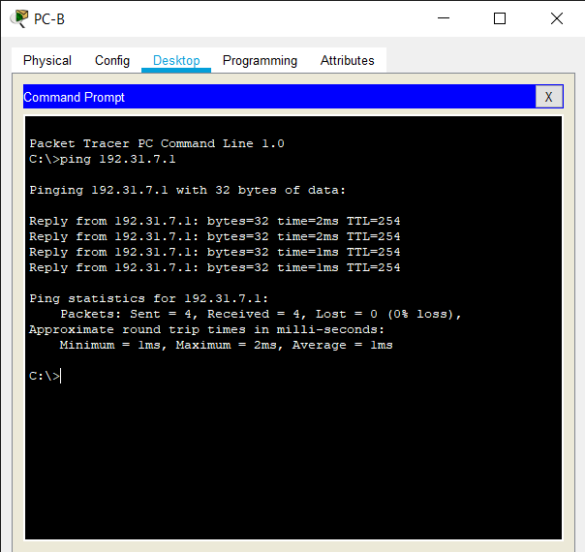

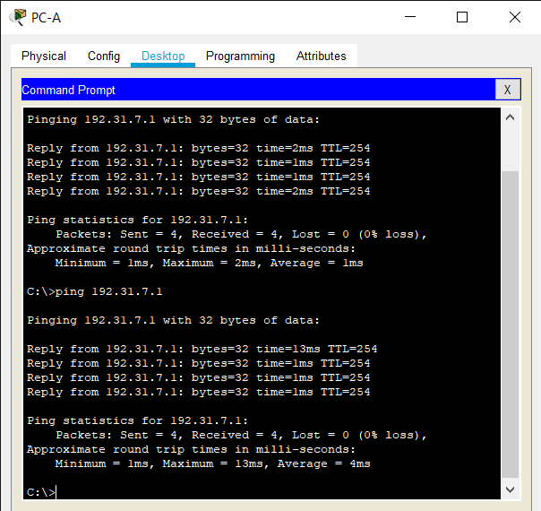

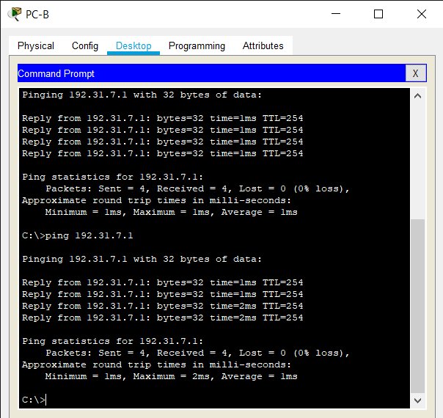

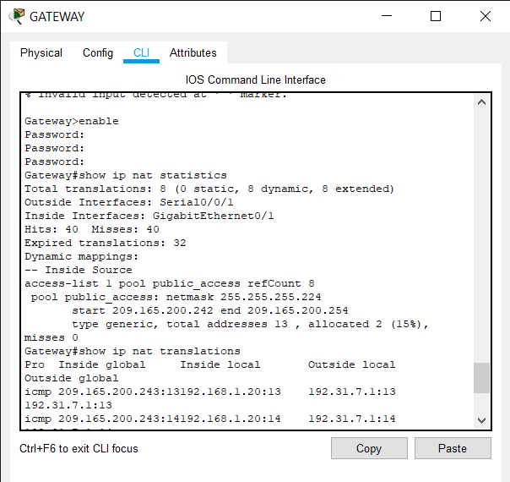

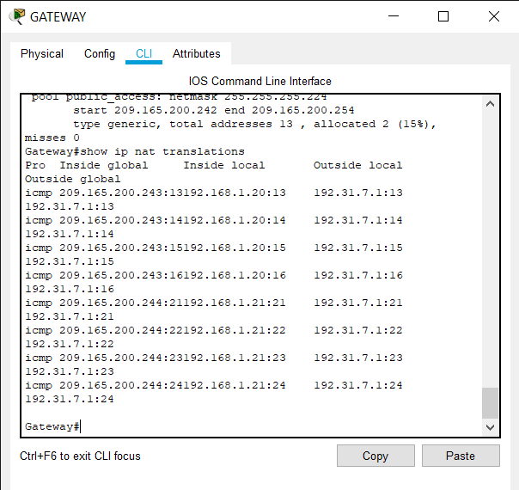

**What is the translation of the Inside local host address for PC-B?**

**192.168.1.21 =** 209.165.200.243

**What port number was used in this ICMP exchange?**

4 port numbers were used for 4 ICMP exchanges for 4 pings.

They are 13, 14, 15, 16.

**What protocol was used in this translation?**

TCP

**What port numbers were used?**

**Inside:** 13,14,15,16

**Outside:** 13,14,15,16

**What well-known port number and service was used?**

TCP service